Name： Date: Year month day
Period: FROM year month day / TO year month day
Main Supervisor’s Name: Signature or Stamp
Research Plan Check Sheet
Please examine the security concern items below and check the box:
(A) Have you read the latest version of ASAFAS fieldwork manual ? YES☐
(B) Have you bought travel insurance for your travel period? YES☐
(C) Have you received information on vaccination and respond with it? YES☐, in preparation☐
(D) Have you filled out the “Emergency Contact in Times of Crisis during Overseas Travel form”? YES☐
(E) Have you shared the important information (photocopies of passport, itinerary, insurance certification)
with your family? YES☐
(F) Does your itinerary include a third country other than your home country? YES☐, NO☐
(G) Did you buy the specified travel insurance while travelling abroad under these conditions? YES ☐
When the itinerary includes third country other than your home country, you must buy insurance with unlimited medical and rescue expenses. You do not need to buy insurance with unlimited medical and rescue expenses when you only go to your home country.
If your destination is your mother country, you do not need to answer the items below.
If your destination is third country, please answer to the following questions.
(H) Do your research area and route belong to the Security Level 4 (red color) or the Security Level 3 (brown) according to Japanese Ministry of Foreign Affairs? YES☐, NO☐
If unsure, please check web site: https://www.anzen.mofa.go.jp/
If you answered YES to questions (H), you are not allowed to travel according to the ASAFAS security policy. Please consult your supervisor and change your research plan.
(I) Do your research area and route belong to Security Level 2 (pale orange)? YES☐, NO☐
If you answered YES to the question (I), please ask your supervisor to write statement of your travel and countermeasures for security during your stay. You must uproad this document to KUIESM along with other necessary documents.

If your research country includes security level 2 (pale orange). please paste or attach the security map of Ministry of Foreign Affairs and your route map.（If your research area is your home country, you do not need to fill out this column. ）
Below is the example of Ethiopia. Please delete these two maps and paste your maps.  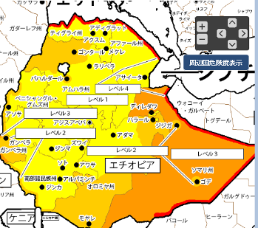 | Below is the example of Ethiopia. Please delete these two maps and paste your maps.  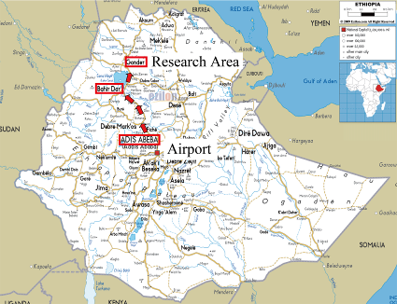
(Continued to the next page)

Pledge
The Applicant, Date of submission, Travel Period, and Travel Destination are the same as those reported to KUIESM.
To: The Dean of the Graduate School of Asian and African Area Studies, Kyoto University

I pledge the correctness of this document, compliance with laws of visiting countries, and security countermeasures during the fieldwork.

With regard to the fieldwork I will conduct overseas, I pledge to bear responsibility for any accident, illness or other incident that may befall me from the time I leave Japan until I return.

Name: (Stamp or Signature)

